# TASK 2 User Management and Access Control

Objective: Set up user accounts and configure secure access controls for the new developers.

1. Create User Accounts – With the below commands user accounts will be created.
   1. Add users Sarah and Mike with home directories:

sudo useradd -m Sarah

sudo useradd -m mike

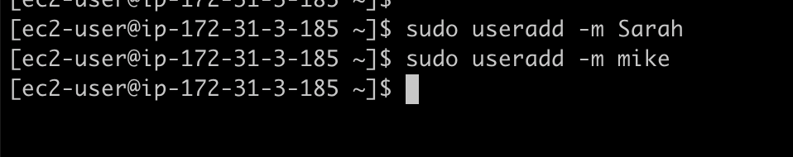

1. Set passwords (input strong passwords): To set the passwords.

sudo passwd Sarah

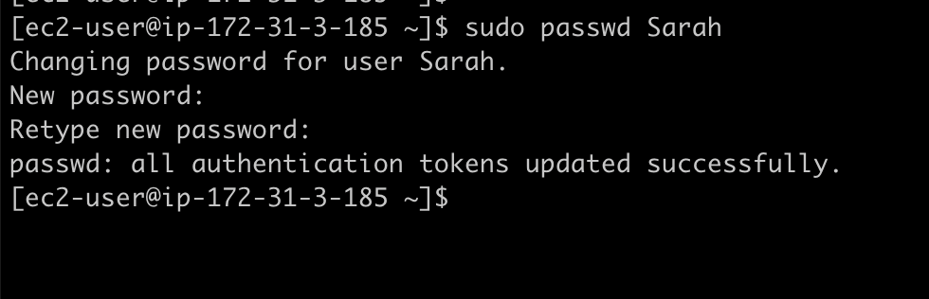

sudo passwd mike

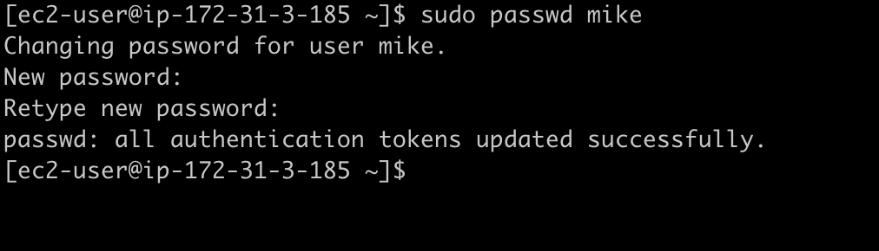

1. Create and Secure Workspace Directories
   1. Make individual workspace directories:

To create the individual secure workspace directories

sudo mkdir -p /home/Sarah/workspace

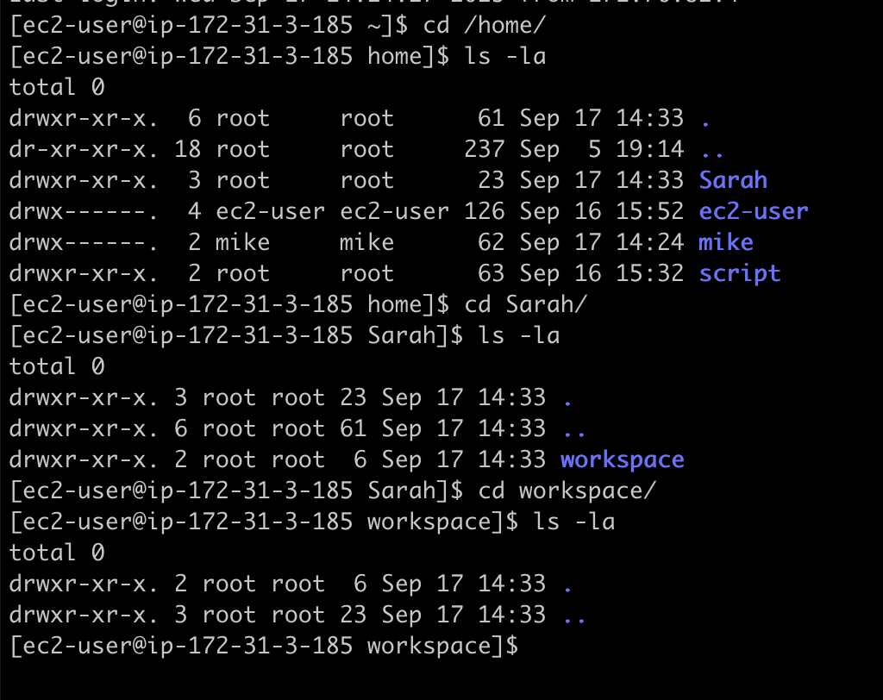

sudo mkdir -p /home/mike/workspace

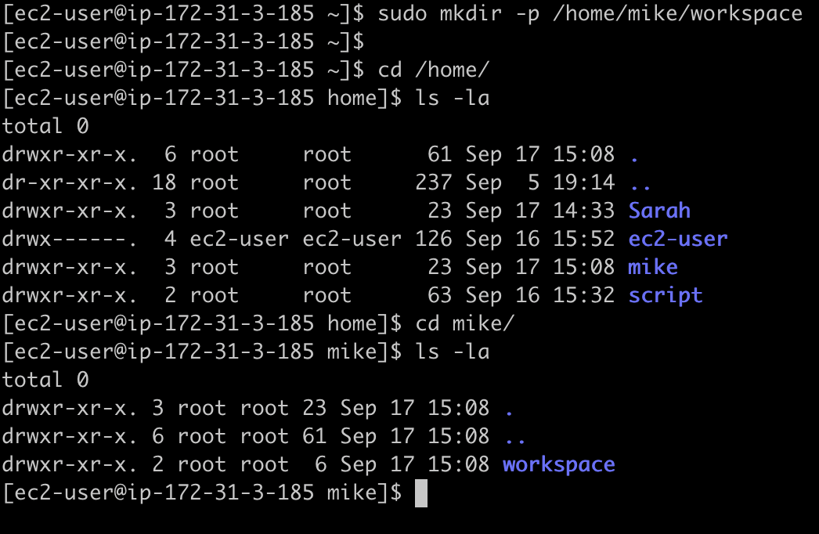

1. Set ownership so only Sarah and Mike can access their directories

sudo chown Sarah:Sarah /home/Sarah/workspace

sudo chmod 700 /home/Sarah/workspace

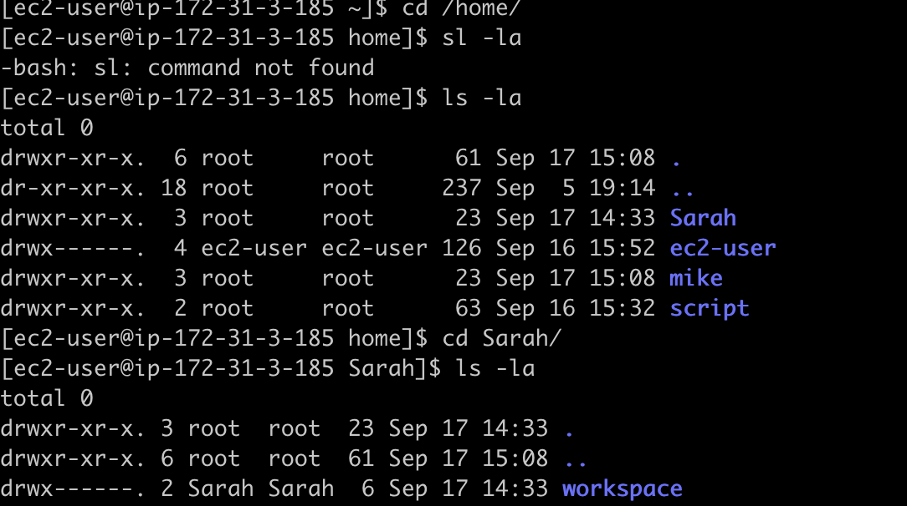

sudo chown mike:mike /home/mike/workspace

sudo chmod 700 /home/mike/workspace

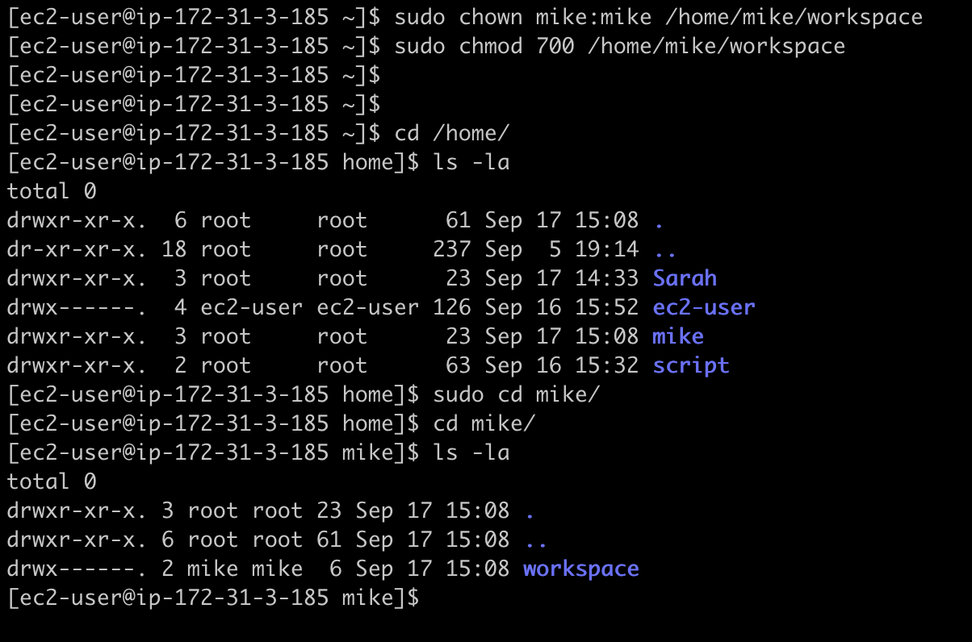

1. Verify permissions: with the below command we can see the permissions.

ls -ld /home/Sarah/workspace /home/mike/workspace

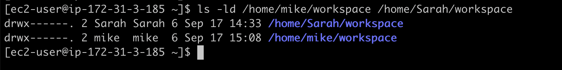

1. Enforce Password Expiry (30 Days)
   1. Set password expiry:

sudo chage -M 30 Sarah

sudo chage -M 30 mike

* 1. Check the settings:

sudo chage -l Sarah

sudo chage -l mike

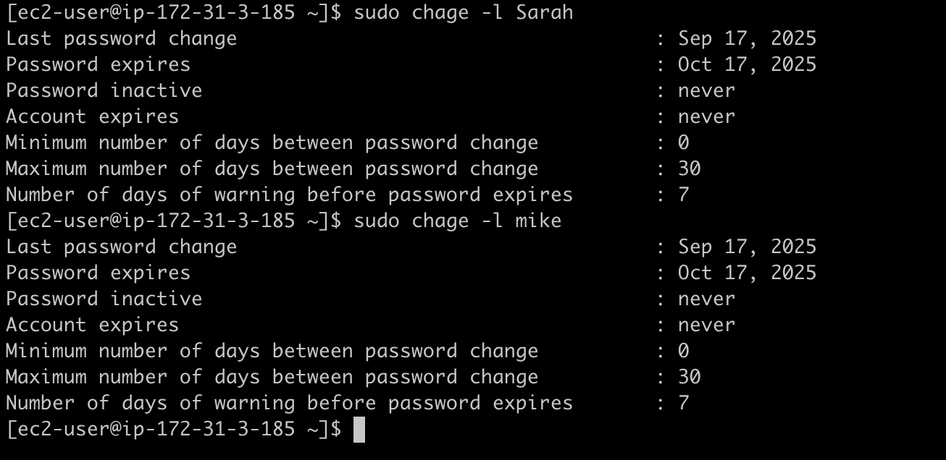

1. Enforce Password Complexity
   1. Edit the password policy (for strong passwords):

sudo nano /etc/security/pwquality.conf

This requires passwords to be at least 8 characters, have lowercase/uppercase/digit/special characters.

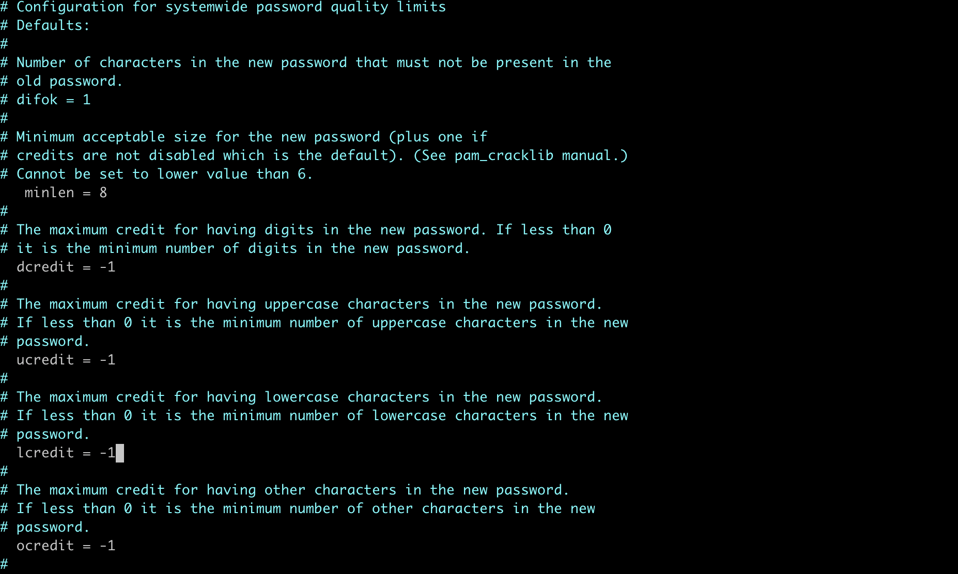

Summary:

* Created User Accounts
* Created the secure workspace directories and set the ownership
* Enforces password policy (ex: 30 days)
* Enforce password complexity for strong passwords.